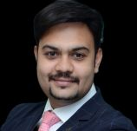
CA. Arpit Jagdish Kabra
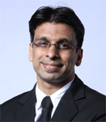
CA. Piyush Sohanrajji Chhajed
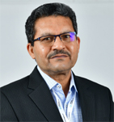
CA. Madhukar Narayan Hiregange
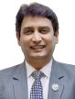
CA. Abhay Chhajed
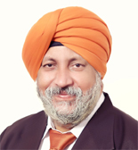
CA. Charanjot Singh Nanda
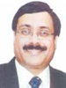
CA. Pramod Jain
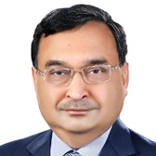
CA. Sanjay Kumar Agarwal
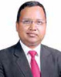
CA. (Dr.) Sanjeev Kumar Singhal
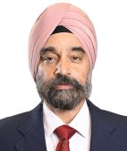
Shri Mukhmeet Singh Bhatia
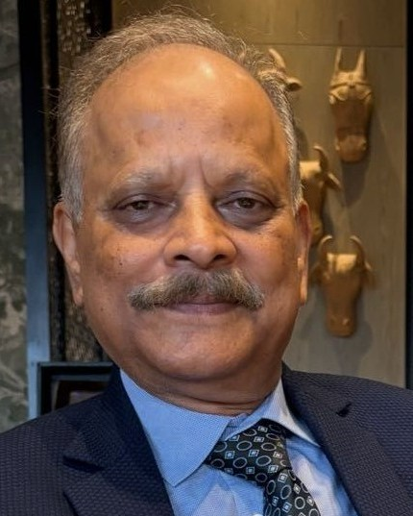
Justice (former) Shashi Kant Gupta

Co-opted Members

CA. Balineni Himachal

CA. Prahlada Rao Kuchimanchi

CA. Balanagu V Guptha

CA. Sarita Agarwal

